ARTSA Presents Private Multi-Artist Exhibitions at Palazzo Nani Bernardo
During the 61st Venice Biennale

Under the curatorial direction of Selcan Atılgan, Head Curator,
the private exhibitions unfold across a historic Grand Canal palazzo,
bringing together contemporary voices in dialogue with Venice’s layered architecture.

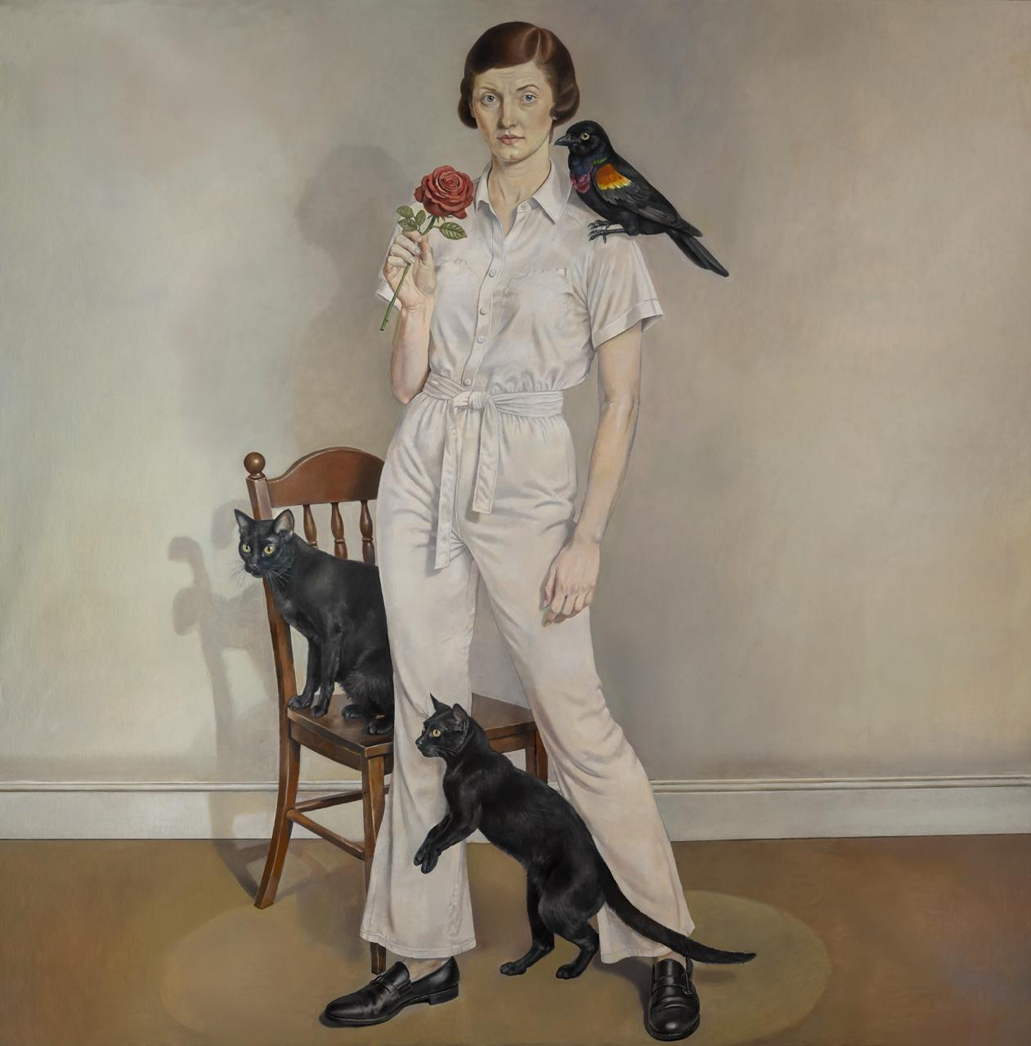

Von Wolfe, Rose and Black Wing, 2025, Oil on canvas, 180 x 180 cm

During the Venice Biennale 2026, the cultural platform ARTSA transforms Palazzo Nani Bernardo into an encounter between past and present. Set directly on the Grand Canal and accessed from the water, the exhibitions activate the palazzo as a multilayered environment spanning the piano terra, the garden, and the piano nobile. Across a sequence of interconnected rooms, contemporary works engage with frescoed ceilings, mirrored salons, and ceremonial interiors, framing Venice not merely as context but as an active interlocutor.

On view through May 30, the project is realized by ARTSA and head curator Selcan Atılgan, Founder and Director of ARTSA. Her curatorial vision frames the project as an inquiry into impermanence and collective consciousness in a time of global uncertainty. The presentation unfolds across two distinct exhibitions within the palazzo, each shaped through curatorial collaborations that structure both the narrative and spatial articulation of the project.

Co-curated by Laurence Dreyfus, Object of Desire is dedicated to the work of Marie Dominique Saramito.

The Open Wound, co-curated by Daria Borisova, brings together artists Von Wolf, KV Duong, Isabella Amram, Savannah Harris, Giuseppe Fracalanza, Geoffroy Pithon, Boris Acket, Ludovic Nkoth, and Naleye Junior, alongside Dennis Miranda Zamorano.

Conceived as a spatial journey, the exhibition series unfolds within the palazzo, originally built as an aristocratic residence on the Grand Canal next to Ca’ Rezzonico. Visitors enter through an artwork-lined ground-floor corridor before ascending to the piano nobile, where historic salons host contemporary interventions while retaining their original character.
The palazzo preserves sixteenth-century layered interiors and a rare Istrian stone wellhead entwined with wisteria at the garden entrance. Its ceremonial spatial sequence and direct canal access frame a setting in which contemporary art engages Venetian architectural history. The garden offers a quiet counterpoint to the interiors, where a structured yet intimate landscape is framed by historic facades and soft greenery.
The exhibitions examine impermanence, migration, and the evolving structures that define contemporary life, positioning artistic practice as both reflection and response within a city shaped by time, water, and constant transition.

Palazzo Nani Bernardo
Sestiere Dorsoduro 3197, 30123 Venice

Vernissage: May 6, 2026
Exhibition: Through May 30, 2026

ABOUT ARTSA
Founded in 2021, ARTSA is an independent cultural initiative dedicated to the conception and production of international exhibitions and cross-regional art initiatives. Operating across Istanbul, Dubai, Hong Kong and Paris, ARTSA works at the intersection of curatorial strategy, art advisory, and institutional collaboration.

ARTSA develops site-specific and pop-up exhibitions worldwide, curates sculpture parks and large-scale installations, and advises private and corporate collections, supporting collection building with a long-term, strategic perspective. The initiative also facilitates global cultural exchange, creating frameworks that connect artists, institutions, and audiences across regions. Its projects are defined by rigorous curatorial thinking, architectural sensitivity, and a commitment to long-term positioning rather than isolated exhibition moments. Through multi-city programming and a sustained international presence, ARTSA builds visibility for artists while strengthening dialogue between regional art scenes. Its approach combines curatorial depth with strategic development, enabling projects that resonate both institutionally and within the market.

ABOUT SELCAN ATILGAN
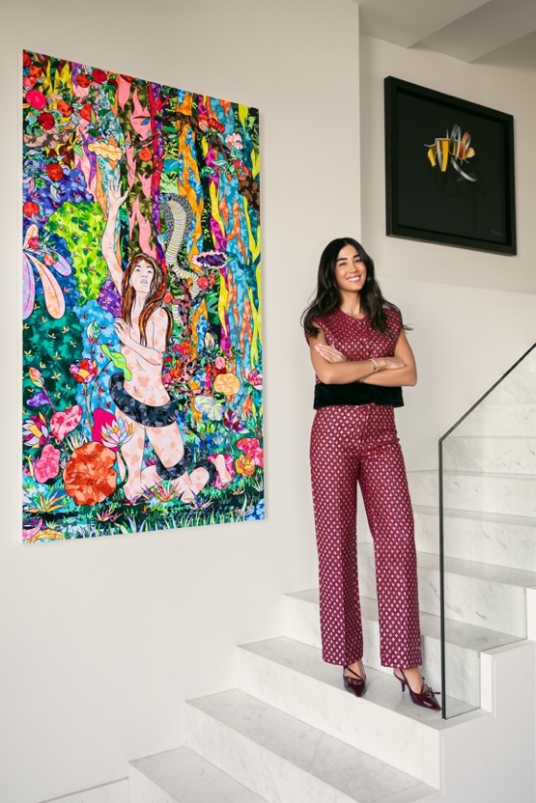
Portrait de Selcan Atılgan / @Milena Accorsini
Selcan Atılgan is the Founder & Director of ARTSA. She leads the organization’s curatorial vision and international development strategy, shaping exhibitions that operate across diverse cultural and geographic contexts. Her work centers on structuring coherent narratives, fostering artist mobility, and creating platforms that connect collectors, institutions, and cultural stakeholders. By aligning curatorial direction with strategic positioning, she has established ARTSA as a cross-regional interlocutor capable of operating between major global art platforms and site-specific environments. Her practice reflects a commitment to long-term institutional dialogue, artist advocacy, and the cultivation of meaningful cultural exchange across markets.

